Mitchell Fontaine
CS-660
02/05/2026
1-2 Activity: Exploring Readability and Adaptability in Python
The three Python scripts demonstrate distinct approaches to control flow, data handling, and abstraction. The imperative approach uses a single for loop to manually iterate through the grades, updating local mutable variables like total, highest, and lowest step-by-step. This provides a low level of abstraction, as the code focuses on the mechanical "how" of the calculation. In contrast, the functional script utilizes high-level abstractions by defining logic through lambda functions and higher-order functions like map, filter, and reduce. It treats data as immutable, generating new lists or values rather than modifying existing ones. The object-oriented implementation encapsulates both data and logic within the GradeAnalyzer class. Control flow is managed through specific method calls, and abstraction is high, as the complexity of the calculations is hidden behind descriptive method names like get_average().
Each paradigm offers unique trade-offs regarding clarity. The imperative script is highly readable for simple logic because it follows a linear, chronological sequence. However, its weakness lies in its monolithic structure. The analyze_grades function handles calculation, state tracking, and printing all at once, which can become difficult to scan as the script grows. The functional script is remarkably concise, with mathematical definitions that are easy to verify in isolation. Its weakness is the potential for clever but cryptic syntax, such as using list(map(print, report_lines)), which may be less intuitive if one is expecting standard loops. The object-oriented script excels in organization, with each metric having a dedicated, self-documenting method. Its primary weakness is the boilerplate overhead, such as the __init__ method and self references, which adds extra lines of code for a relatively simple task.
To modify the scripts to include a median grade, each structure presents different challenges. In the imperative version, adding a median requires sorting the list before the loop and adding conditional logic after the loop, which disrupts the original single-pass efficiency of the script.
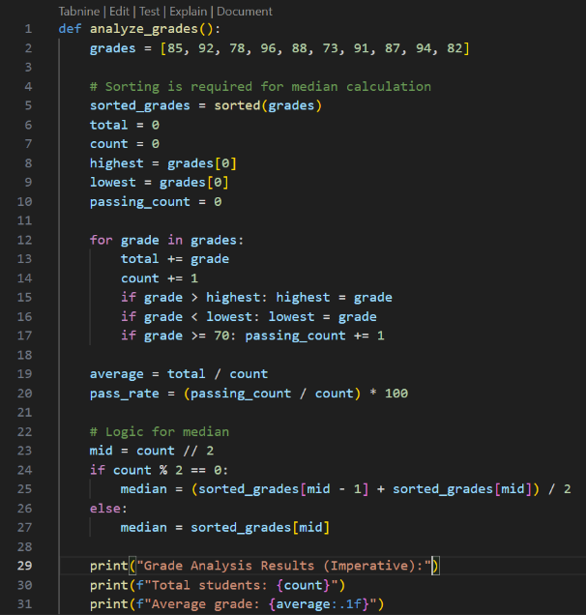
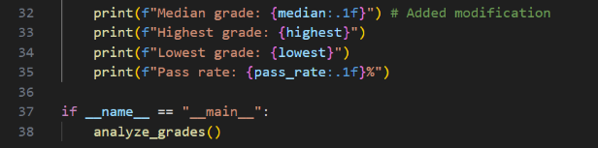
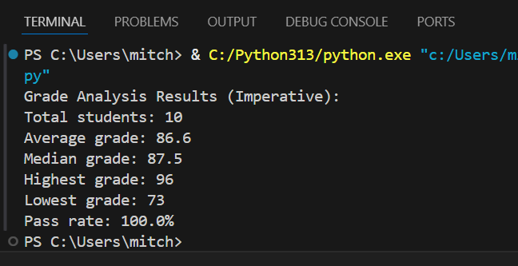

The functional structure supports modification well; one simply defines a new find_median lambda and adds it to the list of analysis functions, keeping the logic modular.
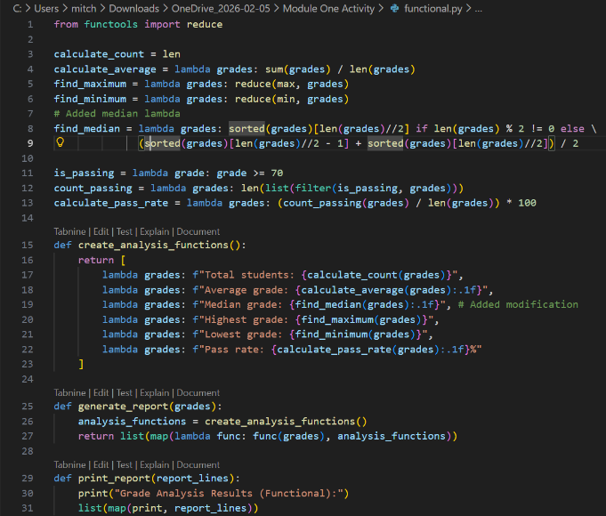
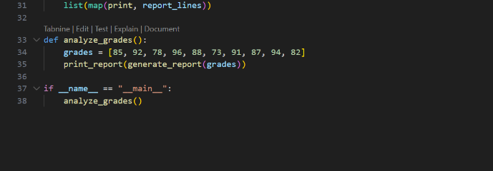
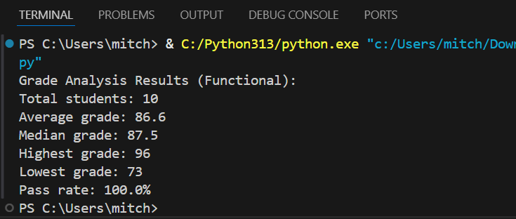
The object-oriented structure is the most supportive for change, as a new get_median method can be added to the class without any risk of side effects or breaking the existing methods.
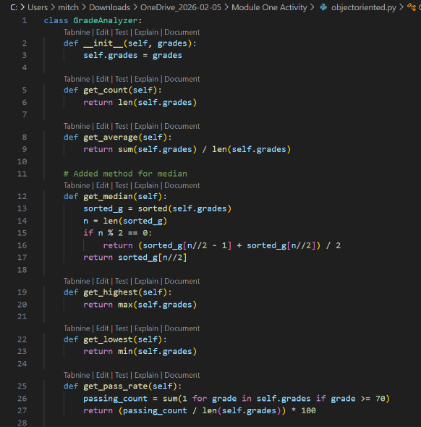
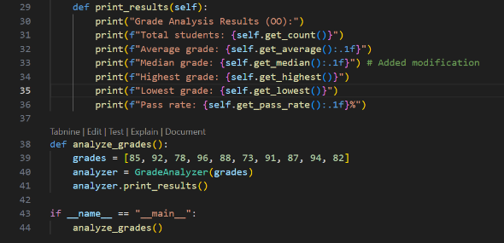
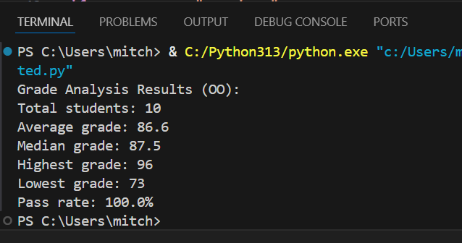

When comparing the three versions, maintainability is highest in the object-oriented script because its encapsulated design allows for easy expansion without affecting existing code. The functional approach also offers high maintainability due to its independent, pure functions. Readability is a tie between functional and object-oriented, whereas the imperative script becomes harder to read as complexity increases. Regarding performance, the imperative script is likely the most efficient as it processes multiple metrics in a single pass over the data. The other two paradigms perform multiple passes, one for each metric, adding slight overhead. Overall, while the imperative script is fast, the object-oriented and functional versions provide a superior foundation for long-term development due to their adaptability and structure.

